**Reg. No. 21BCE1297 Name: Vidhi Shah Date of Practical: 23/03/22**

**Experiment 5**

**Aim:**

Zener diode as a voltage regulator using line regulation.

**Tools and Apparatus:**

* <http://vlabs.iitkgp.ernet.in/be/exp10/index.html#>
* Zener Diode, Resistors, Multimeter, DC Voltage Source

**Theory and Design:**

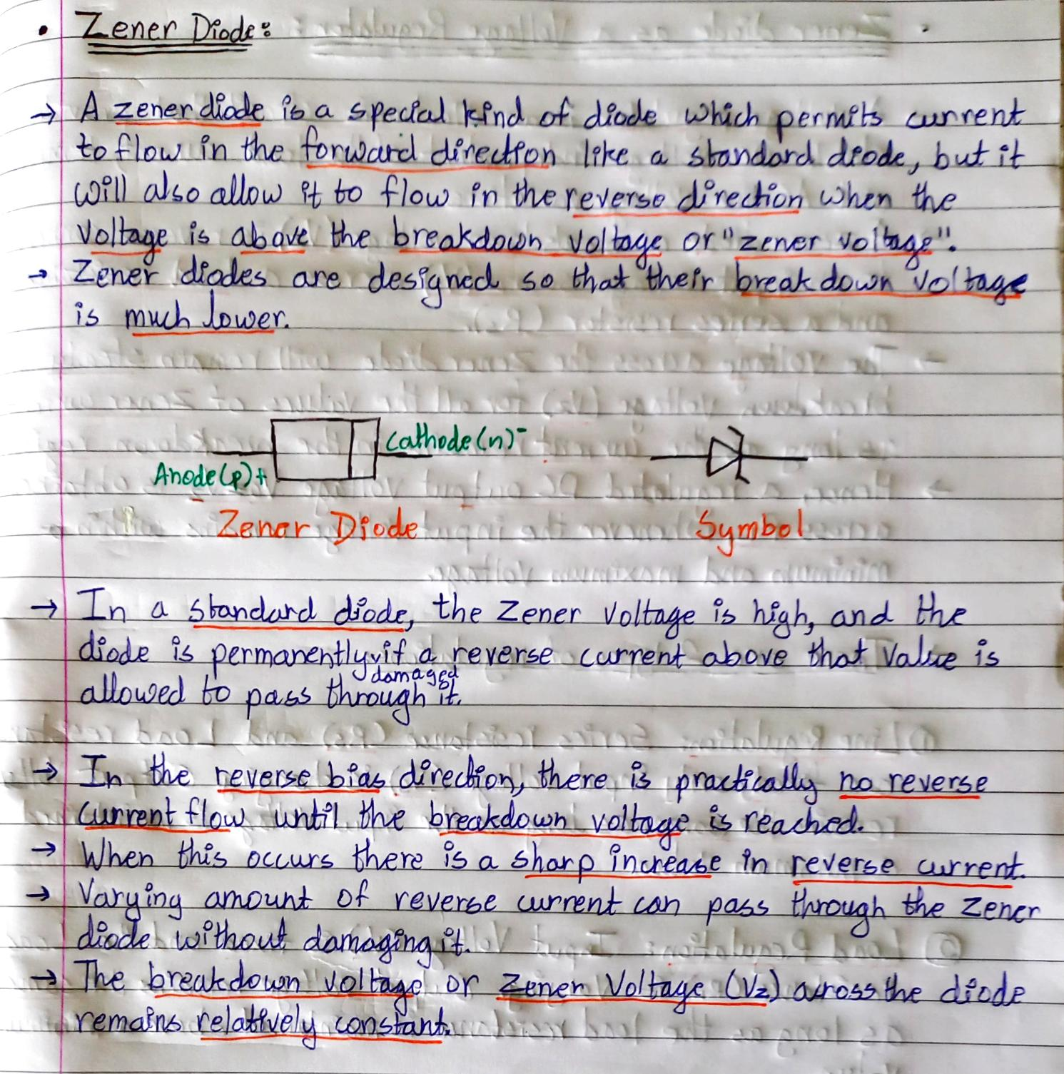

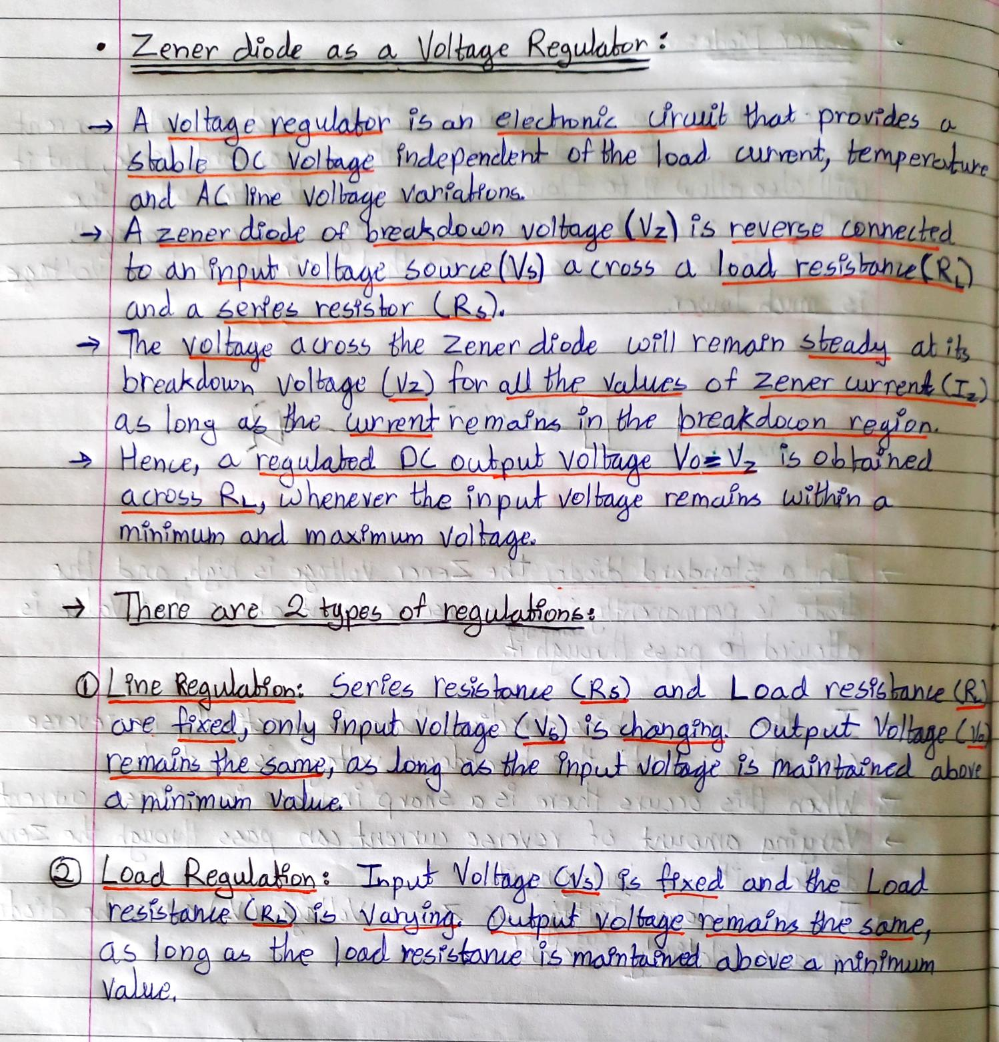

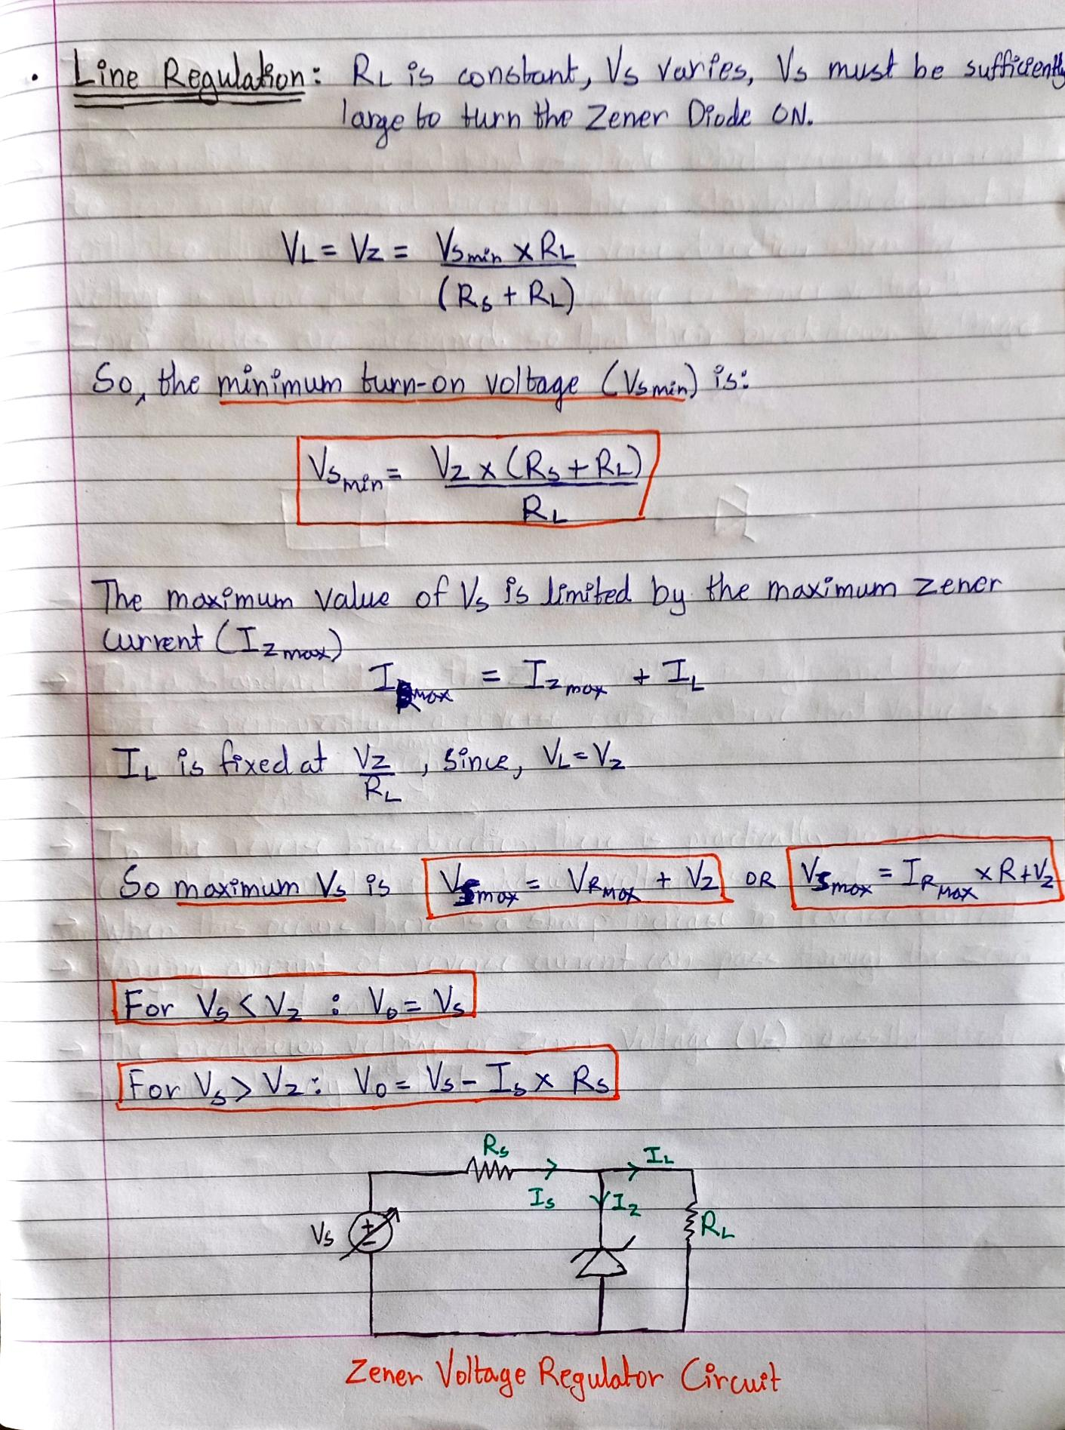

**Simulation Results:**

1. **Zener Voltage (VZ) = 5.1V**

**Series Resistance (RS) = 1kΩ**

**Load Resistance (RL) = 2kΩ**

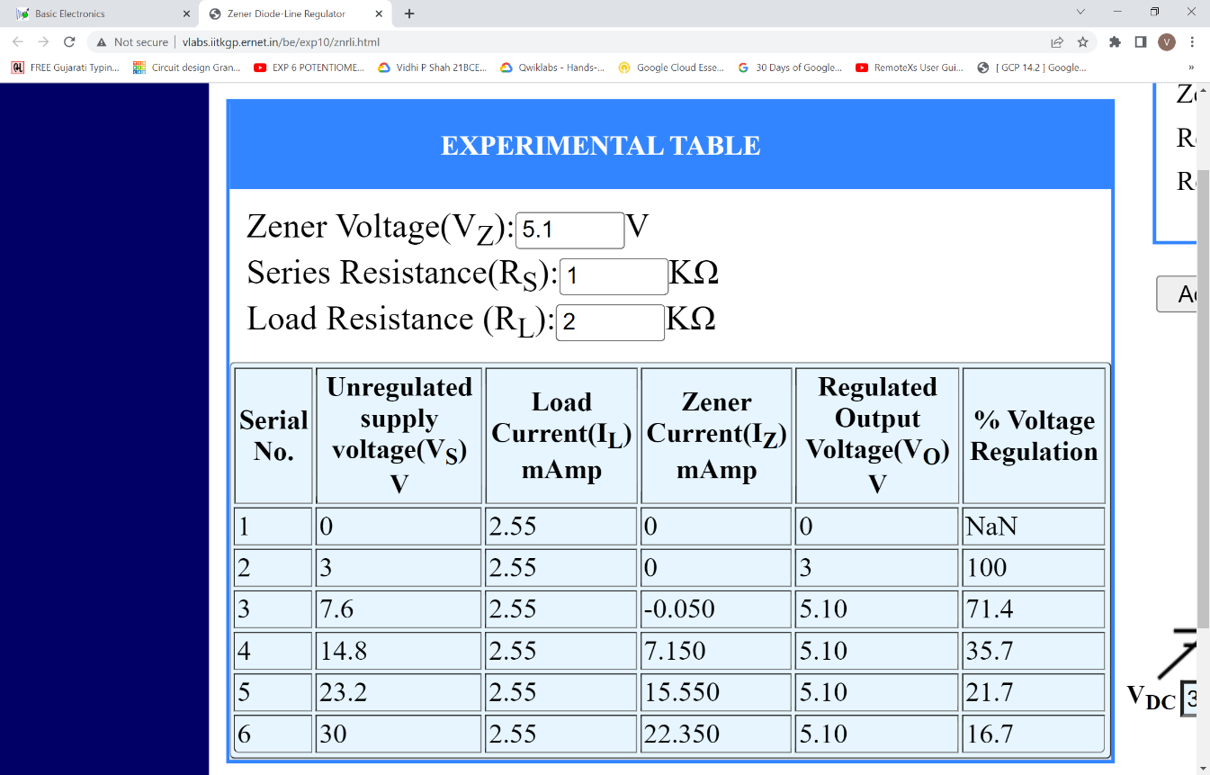

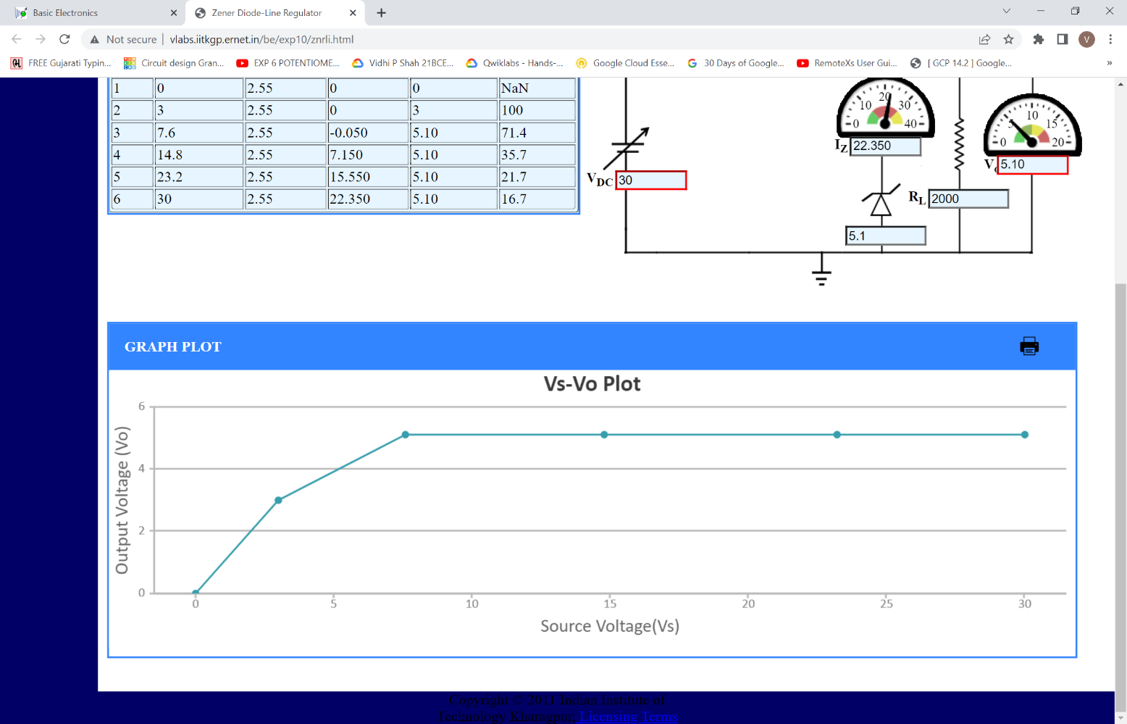

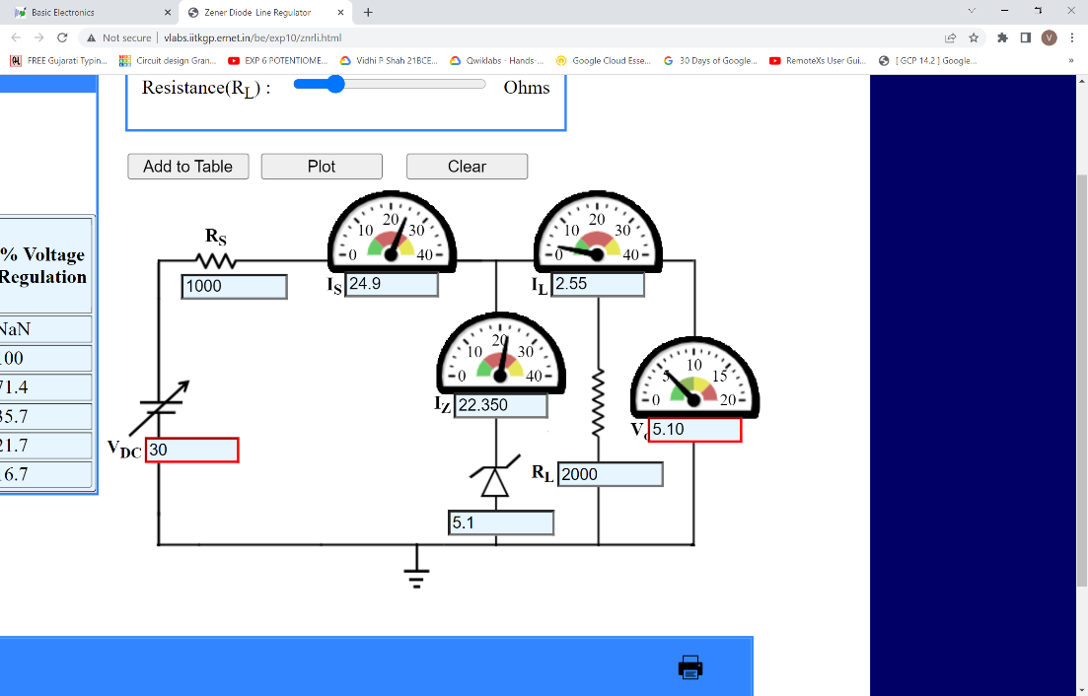

1. **Zener Voltage (VZ) = 5.1V**

**Series Resistance (RS) = 1kΩ**

**Load Resistance (RL) = 5kΩ**

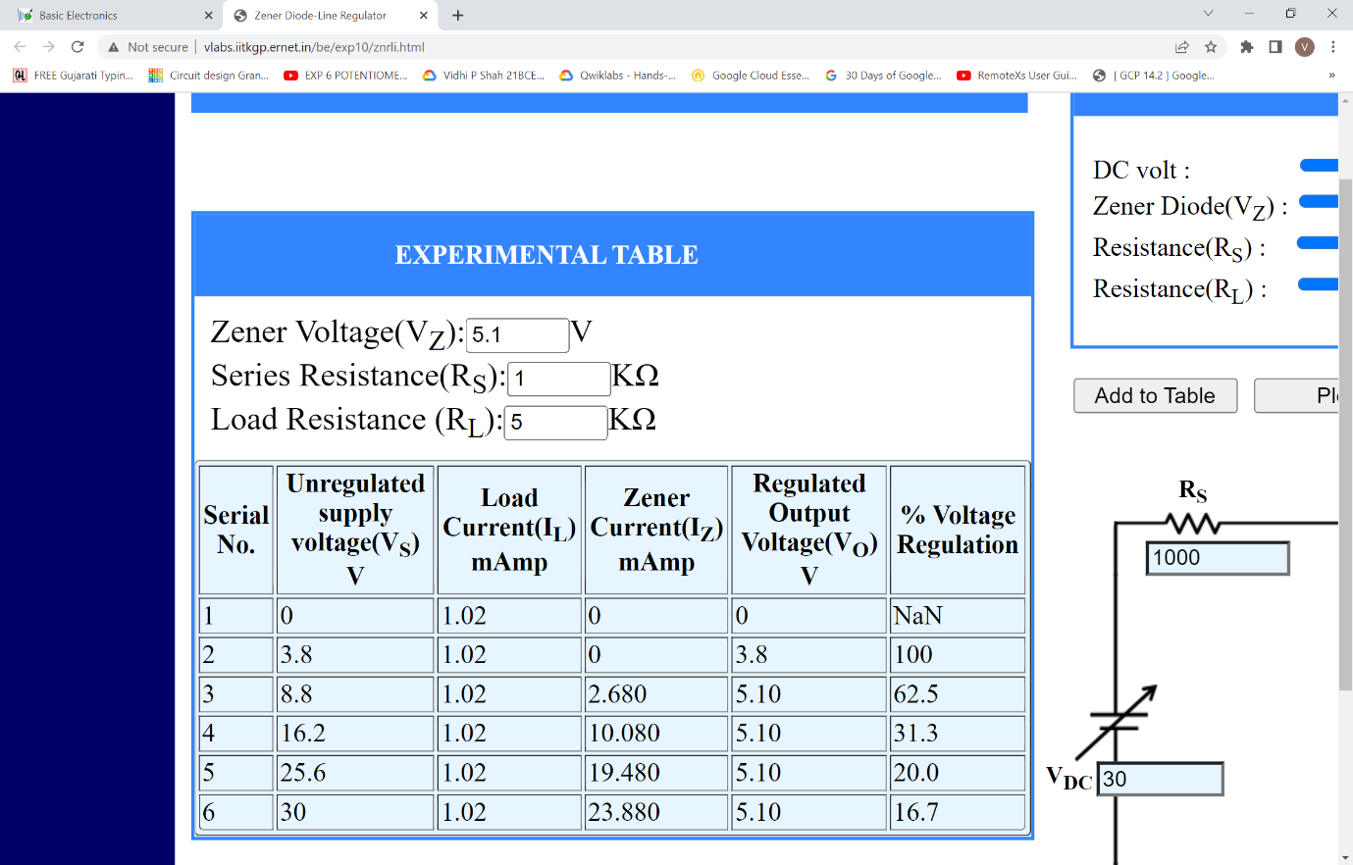

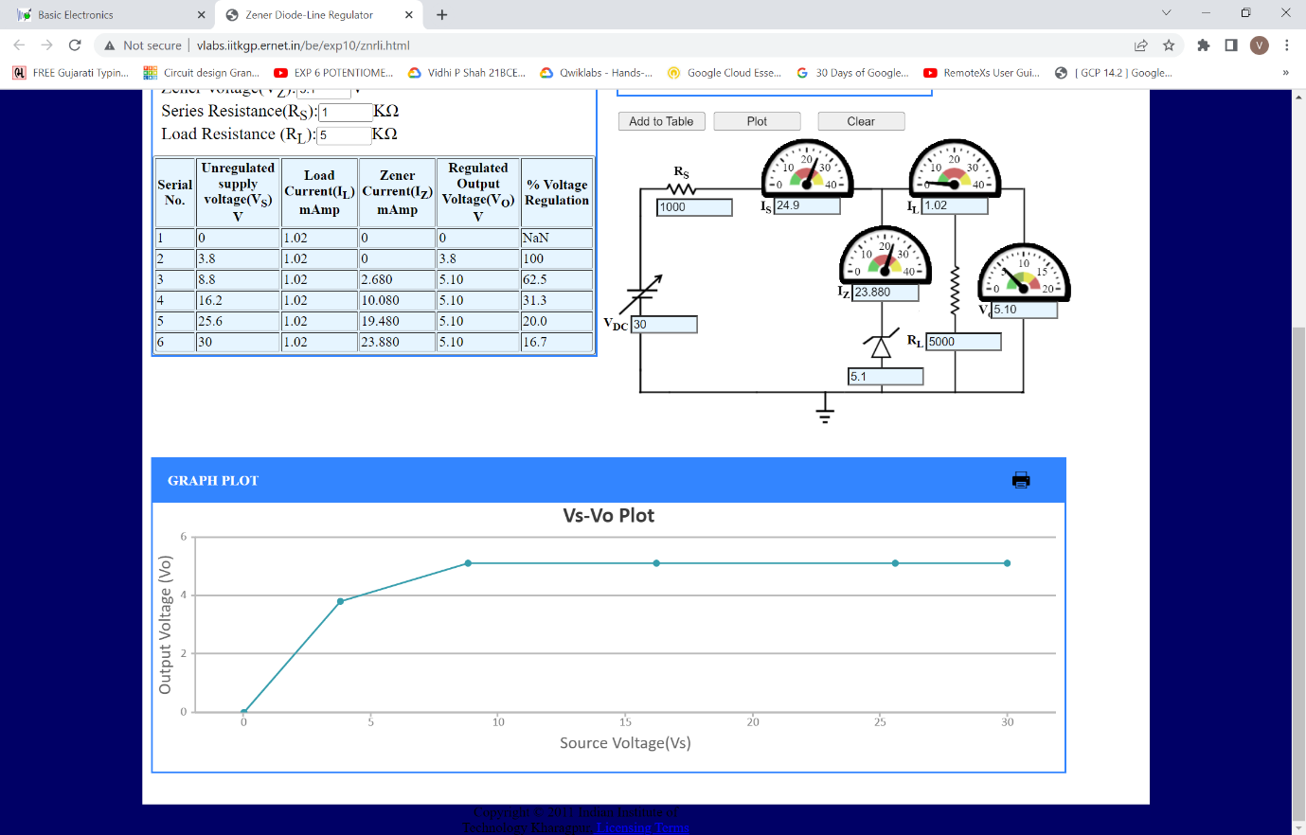

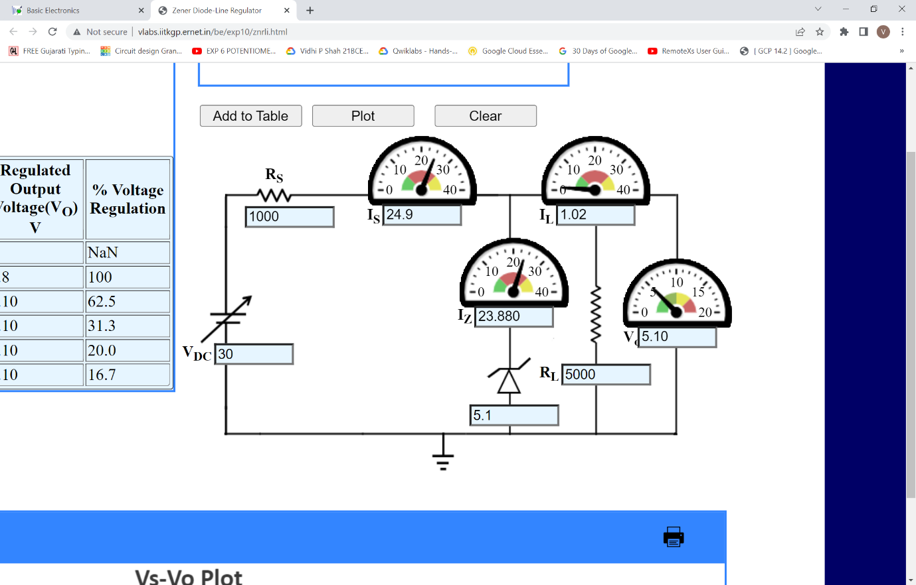

**Conclusion:**

1. For constant value of Zener Voltage (**Vz = 5.1V)** and varying values of VS and RL
   1. Output Voltage is constant, **VO = 5.1V**
2. For constant value of **Vz = 5.1V** and varying values of VS
   1. **RL = 2kΩ**
      1. Load current is constant, **IL = 2.55A**
   2. **RL = 5kΩ**
      1. Load current is constant, **IL = 1.02A**

**Inferences:**

1. For all values of Source Voltage greater than Zener Voltage, Output Voltage is constant and is equal to Zener Voltage.
2. If Source Voltage is less than Zener Voltage, Output Voltage will be equal to Source Voltage.
3. To get a straight line graph of constant voltage always keep Source Voltage greater than Zener Voltage.
4. **IS = IL + IZ**
   1. IS and IZ are regulated in such a way that IL remains constant for a constant value of RL and therefore VO remains the same.
   2. If RL changes then all current values change accordingly (Inversely Proportional) and therefore VO still remains the same.